

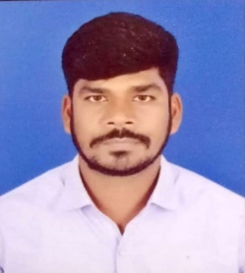

Ref No : TEC/2024/04

**TO WHOM IT MAY CONCERN**

This is to certify that **Mr. Anil Kumar Swarnkar S/O Sri Ramkrisna Swarnakar** has beenworking in our organization as a **“COMPUTER TEACHER CUM ACCOUNTANT”** from 06th July 2022 to till date. Working time is 02:00 – 07:00 PM.

Mr. Anil Kumar Swarnkar was responsible for:-

1) Delivering engaging and interactive computer lesson to

students.

2) Preparing lesson plan, study materials and conducting

assessments.

3) Guiding students in practical of multimedia application.

He is hardworking, dedicated and reliable professional with excellent communication and technical skill. His ability to connect with students and simplify complex topic has been commendable.

We are confident that he will excel in his future endeavors and contribute significantly to any organization he joins.

We wish him all the best in his future career.

For THE EUROPEAN Date :- 04-12-2024